
--------------------------------------------
Team LEBOB’s
Innovations
2025 Unearthed
--------------------------------------------

Members:
Kingsley Wong
Sean Chan
Oliver Liu
Leven Shi
Subesh Sukumaran
Yuxin (Chris) Wang
Aaron Zhang
Andre Nijman

Brainstorm
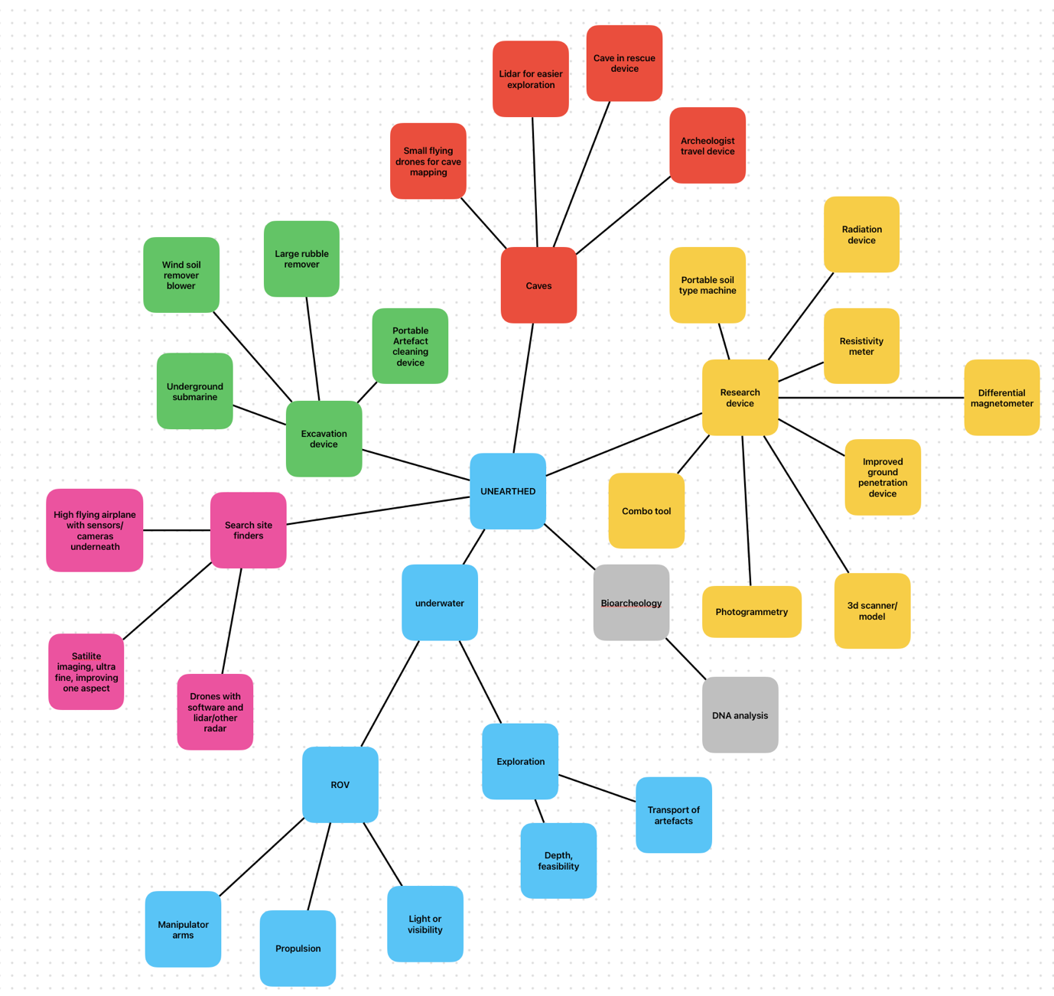

As a team, we had a couple of different preferences. We would have liked to do something that was coding related as well as mechanical, and which involved electronics. However, as a team we were flexible and didn’t really mind what we did. We ultimately decided upon manipulator arms, as they are a rapidly improving field, that was doable to a group of school students that had at their disposal 3D printers and basic electronic parts.

Problem
Archaeologists are facing hard times trying to recover fragile, broken or small shards from the sea floor, relying on cheap, two finger manipulator hands on ROV arms, that were originally intended for oil, mechanical or industrial use. These clumsy setups could lead to the inability to recover artefacts, or even worse, the destruction of those artefacts. They also have severe and hard limits on the size and shape of objects they can carry.

Research

Websites to visit
Assessing damage and predicting future risks: A study of the Schilling manufactured Titan 4 seven function manipulator during 2017 - 2022 – DONE https://www.sciencedirect.com/science/article/pii/S002980182302666

Collision Detection for Underwater ROV Manipulator Systems - https://pdfs.semanticscholar.org/2327/89da0cdc7c8ff9b114b9383fc5ce8a49956a.pdf

Underwater manipulators: A review – DONE https://www.sciencedirect.com/science/article/pii/S002980181831030

Lightweight underwater robot developed for archaeological surveys and excavations - https://robomechjournal.springeropen.com/articles/10.1186/s40648-023-00240-4

https://www.imca-int.com/resources/safety/safety-flashes/0301-rov-personnel-injury/
Sivčev et al., 2018a; Bogue, 2015; Petillot et al., 2019; Antonelli, 2014

Notes
Underwater manipulators: A review
Notes:
- Underwater manipulators are used in many ways: grasping, lifting, handling objects underwater
- Factors that affect the performance of these include hydrodynamic effects (drag, added mass), buoyancy, structural stiffness, joint design, reach, torque, capability
- Reach is also important
- Manipulator arms are considered the most suitable tool for executing sub-sea operations
- Majority of existing arms are anthropomorphic
- Most arms are designed for a single purpose, ie lifting large, heavy objects, or attaching a gripper to an underwater object
- Most working class ROVs have two manipulator arms, one simple, strong one to hold onto the object, and a smaller one to do the actual job
- Most common materials used are metal alloys, including titanium Ti 6-4, anodized aluminum alloys (5083, 6082 T6, 6061 T6, 7075 T6, A356), stainless steel alloys (316, 630, 660), as well as some plastics (Polyethylene)
- Key factors in those materials include high corrosion resistance, relatively high strength and ease of manufacturing
- To reduce weight and actuator burden, buoyant materials have been tried
- Commercially available arms typically are rated at 3000m to 6500m of sea water, however some can reach 7000m
- Some have been developed for full ocean depths 11000 msw
- size of underwater manipulators is described as a parameter called “reach”
- represents the length of the whole manipulator kinematic chain
- reach of existing underwater manipulators from 0.5 m up to 2.4 m
- max wrist torque ranges from 8Nm to 250Nm
- listing and carrying vary from 5 kg to 500 kg
- rotary low torque rated for max of 75 Nm
- manipulator arm weight in air varies from 6kg to 150kg
- commercial arms come with interchangeable grippers with specific purpose
- common gripper type is parallel acting jaws that has a slot for a standard T-bar handle
- primary function to grip a variety of different objects and tools
- different grippers include three/four finger intermeshing jaws, two/three finger floating jaws, scissor jaws, suction foots
- grippers are usually hydraulic
- grip strength range from 35 kgf to 652 kgf
- both experimental and commercial arms have between 3 to 6 degree of freedom (DOF)
- 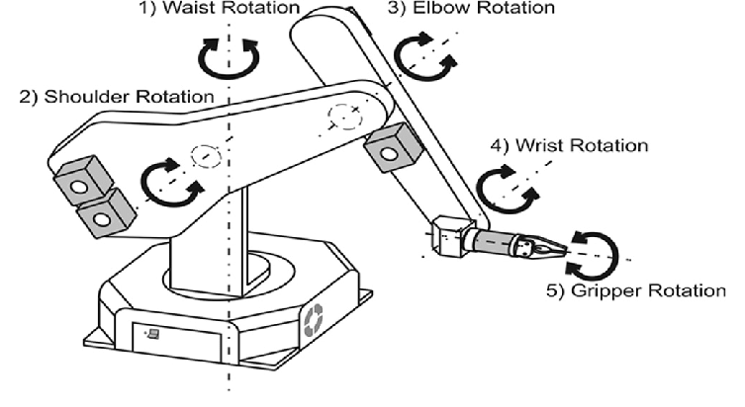
Example of a 5 DOF manipulator arm
- reason for this is that 3 DOF is sufficient for achieving arbitrary position and 6 is sufficient for achieving both arbitrary position and orientation of the end effector
- term “n-function” generally used to describe number of actuators used, one for the gripper and the rest for arm movement
- underwater arms with 7 or more DOFs, not including gripper actuator, are not very common, but do exist
- True 7 DOF manipulator arms are said to be inherently redundant from a kinetic standpoint
- This can be used later for redundancy or to achieve secondary objectives
- Benefits of sea water hydraulic operated manipulator arms include : low viscosity, high power density, non-flammable properties and zero environmental impact
- Disadvantages: corrosive and abrasive properties, lubrication and sealing issues, unsuitable working temperature range, etc
- All existing manipulator arms now either use oil hydraulic or electricity, both of which have advantages and disadvantages
- Proposed dual, both oil and electricity, however not commercially viable yet
- Biodegradable oil has now minimized the impact of fluid leaks
- Generally, hydraulic actuators can produce an output force/torque much larger than the force applied on the input without the use of mechanical components such as gears and levers (direct drive)
- They are a necessity for the implementation with electric actuators
- Thus, hydraulic systems have higher power to weight ratio (payload capability) which goes up to the order of three for the existing commercial hydraulic underwater manipulators
- Whereas ratio is one or less for the electrical ones
- Hydraulic benefits lead to majority of commercial arms being hydraulic
- Actuators with limited motion e.g. piston cylinders and rotary vane actuators are used to drive manipulator joints
- Some cases gearmotors, type of hydraulic motor with continuous motion are used for wrist joint actuation
- Hydraulic manipulator arms suffer from poor positional accuracy compared to electric arms, and are not suited for fine control of the interaction force with the environment during contact tasks
- Another problem is fluid leaks, which is almost impossible to solve, which brings demand for higher quality material and construction, resulting in higher prices
- Also, hydraulic arms require additional infrastructure, like pumps and tanks, while electric don’t, requiring only electricity which can already be found
- Electric arms are less frequent in commercial use, however are often used for experimental or custom made arms
- Actuators commonly use brushless DC motors, with large reduction ratios
- To stop water ingress, oil is used, which also helps with lubrication and cooling
- To prevent using external wires that could result in possible entanglement, power and signal cables are fed through the same hoses used for pressure compensation
- Main advantage of electric arms are its precision and force/torque control
- Most aren’t used in operations as they lack the speed, reliability and strength requirements
- Different types of operating systems
- One which has each actuator/joint as a different input-output system, which combined to control the entire arm, this is known as a decentralized control scheme
- The second type is the opposite, a centralized control scheme, which takes dynamic interactions between the joints into account
- When designing a control system, you need to take into consideration the specifics of your ROV as your drive system, different actuators, etc can impact the control system, if you’re using a hydraulic system, the viscosity of the oil and its pressure and flow can
- It is extremely difficult to model and control a manipulator arm, as hydrodynamic effects such as buoyancy, drag and lift forces as well as external forces like waves, currents etc all can affect manipulator arms. The temperature, depth, salinity, etc can also affect the hydrodynamic affects as well as the arm itself
- Control schemes which integrate proportional (P), integral (I) and derivative (D) terms in different variations offer simplicity of implementation and low software costs
Reference https://www.sciencedirect.com/science/article/pii/S0029801818310308

Assessing damage and predicting future risks: A study of the Schilling manufactured Titan 4 seven function manipulator during 2017 - 2022
Notes:
- Leaks or damage to the seals of the manipulators arms are the most common cause of damage
- The jaws or fingers of the manipulator arms are the element most exposed to damage
- There is a correlation between operator errors and manipulator damage
- It is possible to identify possible preventative measures against future failures
- The Titan 4 is the most widely employed equipment on work class ROVs world wide
- Depth for scientific work can go between a few meters underwater to 10,000 m (Cochran, 2019; Kennish, 2019).
- only around 5% of ROV shares are used for scientific research
- Underwater Vehicle Manipulator Systems (UVMS) typically resemble human arms and have interconnected rigid arms with revolute joints and end-effectors like grippers and tools
- Often also have cameras or lights
- designed for different purposes, such as lifting heavy objects, attaching detachable grippers to sunken objects, fixing underwater vehicles to structures or walls, inspection tasks, dexterous intervention operations, and more
- Work class ROVs typically have two manipulators, with one serving to hold the ROV near the structure while the other performs the actual intervention task (Sivčev et al., 2018a)
- Tasks executed by underwater manipulators include …. biological and geological sampling, archeological work, and more
- Most manipulator arms are located at the front, but some can be found located in the back
- Most are operated by pilots and co-pilots, however limited visibility in murky waters and poor camera angles can lead to collisions and significant damage
- A collision detection mechanism has already been developed
- Titan 4 has good corrosion resistance, a key factor for underwater mechanical mechanisms
- Key parts of the Titan 4 include azimuth, shoulder, upper arm, elbow, forearm, pitch & yaw, wrist, and jaw
Reference: https://www.sciencedirect.com/science/article/pii/S00298018230266

Analysis of Lightweight Materials for Robot Manipulators
Notes:
- Aluminum is widely used for manipulators, because of its good mechanical properties
- For industrial robot designs, a material with low density and high rigidity is preferred
- Composite materials often can perform better than aluminum, however, are more expensive and difficult to manufacture
- Comparison between aluminum and a carbon fiber composite
- 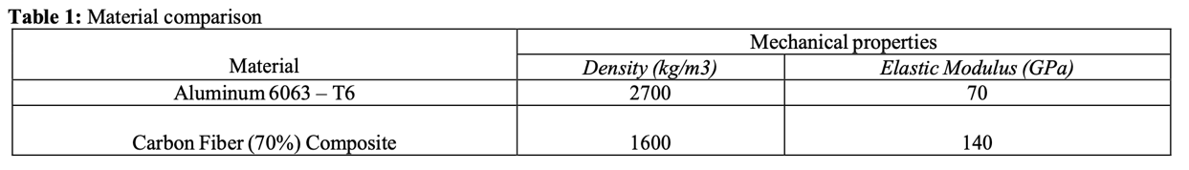
- Traditional heavy rigid arms are designed with stiff links, so the links dynamics can be ignored, and the position of the entire arm can be found through the positions of the actuators
- In flexible robots the links are no longer assumed to be rigid, so when there is movement, unwanted vibrations may change the position of the arm and tip, making positional errors more likely
Reference: https://www.ajbasweb.com/old/ajbas/2015/May/877-882.pdf

Materials for ROVs – Top 5
Notes:
- Anodized aluminum
- Benefits: corrosion resistance, durability, relatively light,
- Drawbacks: may not be suitable to deep-sea applications where more durable materials like titanium would be preferred, coating may rub off in abrasive conditions
- Titanium
- Benefits: exceptionally strong, low weight, corrosion resistance, excellent fatigue resistance, can withstand high pressure and aggressive fluids
- Drawbacks: much more expensive than aluminum, fabrication can be more complex, large carbon and environmental footprint
- Stainless steel
- Benefits: corrosion resistant, good strength
- Drawbacks: much heavier than other options, may require additional treatments to make for optimal corrosion resistance
- Plastics and composites
- Benefits: good balance of weight, strength and corrosion resistance, can insulate against electricity, good seals
- Drawbacks: limited high temperature resistance, limited depth capacity, not suitable for deep sea applications
- Ceramics
- Benefits: excellent corrosion resistance, wear resistance and thermal stability
- Drawbacks: brittle and require careful engineering to prevent failure under mechanical stress or impacts, least versatile and very rare to see ceramics in main body of ROV, more in specialized applications like sensors
- In General:
- Materials that are needed in ROVs typically require three main properties:
- Corrosion resistance, the sea is extremely salty and can rust or damage materials if submerged for enough time
- Strength, deep sea pressures or impacts with creatures or rocks can damage structural elements, which can lead to malfunctions or at worse, water leaking into the electronics, resulting in an unusable ROV
- Low weight, less weight requires less energy to move in water, making the ROV more energy efficient, and reducing the amount of power the movement motors require, giving more to the main manipulator arms.
Reference: https://seamor.com/materials-for-rovs-top-5/

Specifications of existing manipulator arm models: 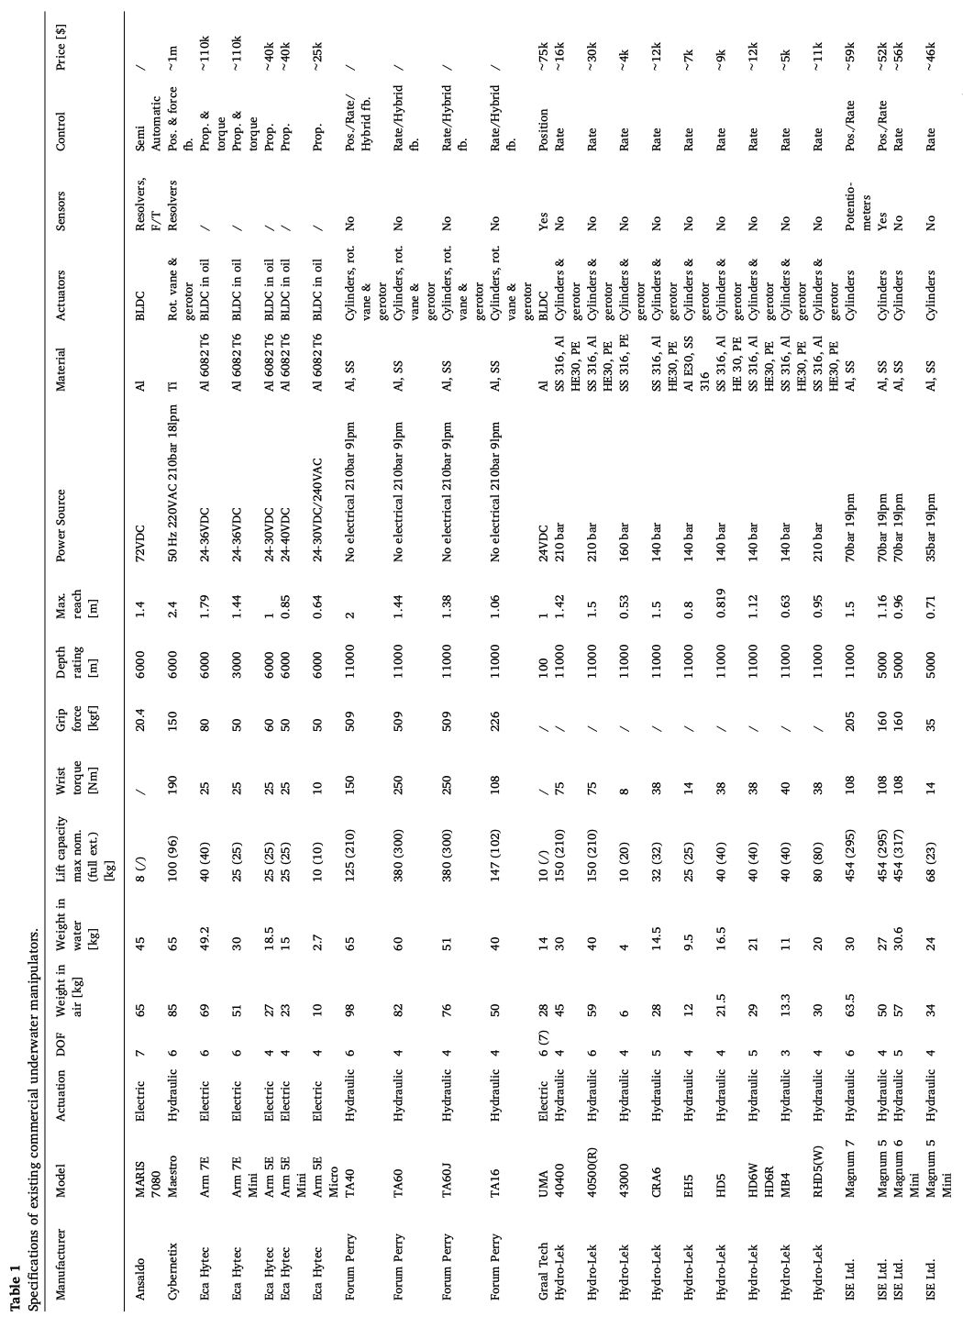

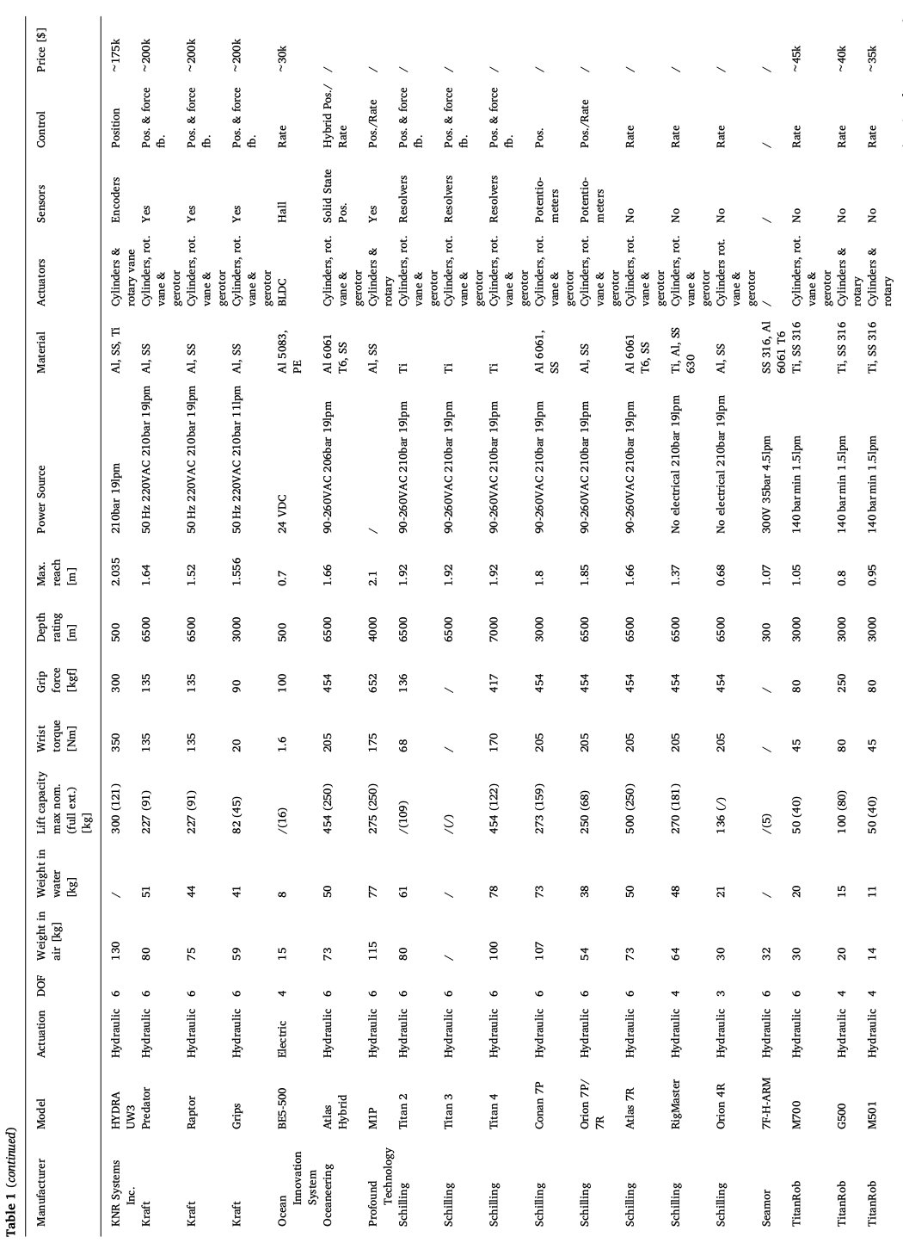

Solution
Our solution is to use a combination of existing technologies, applied in creative ways. Firstly, we use soft foam pads on the tips of the fingers on the gripper to help reduce the chances of breaking delicate artefacts. Secondly, we apply pressure sensors beneath the pads. This gives a readback to the operators, as well as give ROV operators the option of running our code, which stops the actuator when the pressure value reaches a certain threshold. Thirdly, we attach all of the pads and the pressure sensors to a rotating surface. This allows the pads to always have decent contact on the object, making awkward positions more feasible. They can also set presets for different objects, like one for a soft object like coral or one for a harder object like limestone.

Testing and Results
We used a set of 4 objects, a pot, a treasure chest, a bone and an anchor. 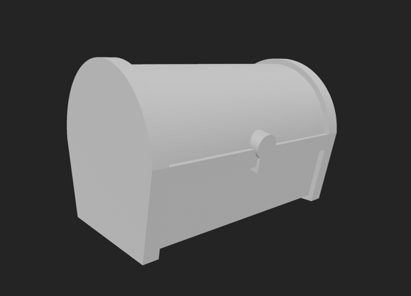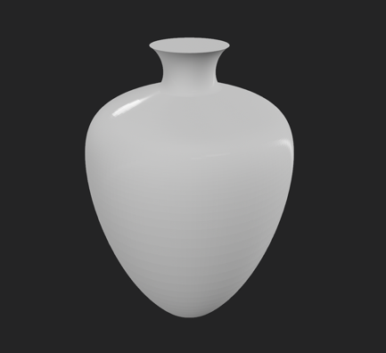
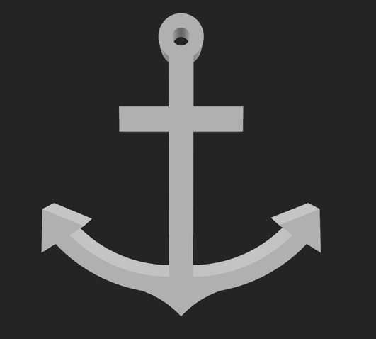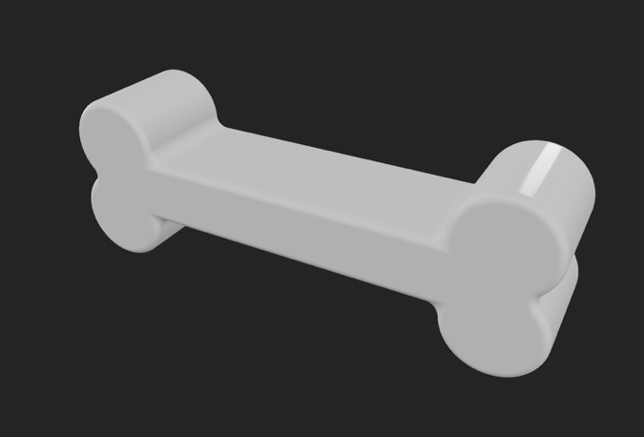

We chose this set of items because they are a diverse range of items, with different shapes and features. For example, the bone and the anchor are both quite long items, however one has two sets of holds that could provide grip for a manipulator arm, however the bone has little places to grip, besides the two ends. The chest and the vase are also quite similar, as they are both quite stout objects, however the chest is a rectangular object, with grooves in the side for quite easy grip, while the vase is a smooth, circular object, and only has the head portion to grip for the arm.

Object | Number of attempts (4 fingers) | Number of attempts (2 fingers) | Pressure values to grip
Bone | 2 | 4 | 26 g f
Anchor | 5 | 4 | 96 g f
Vase | 3 | 5 | 411 g f
Chest | 3 | 3 | 288 g f

Feedback

Experts emailed
Dr John McCarthy
Associate Professor Jonathan Benjamin
Chelsea Wiseman
Michael O’Leary (UWA)
Jerem Leach
Ingrid Ward
Hiro Yoshida

Institutions emails
Australasian Institute for Maritime Archaeology
Minderoo UWA Deep sea Research Centre
Western Australian Museum, Maritime Archaeology Department

Emails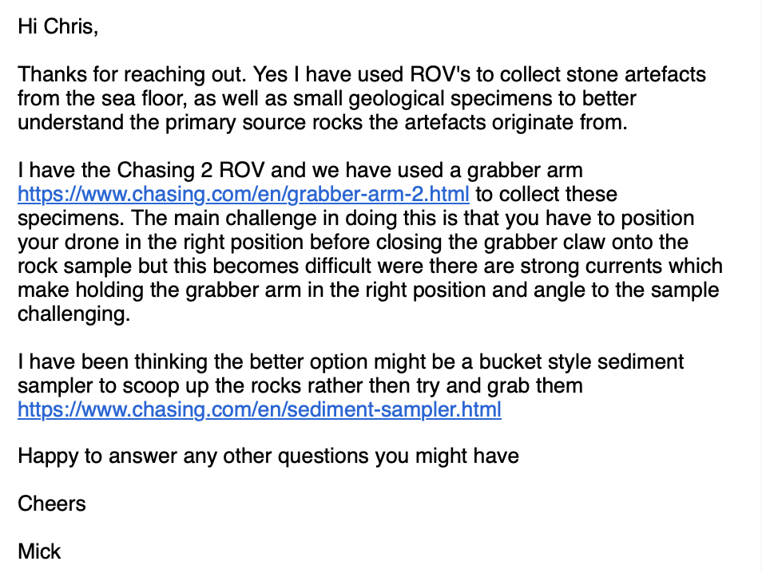
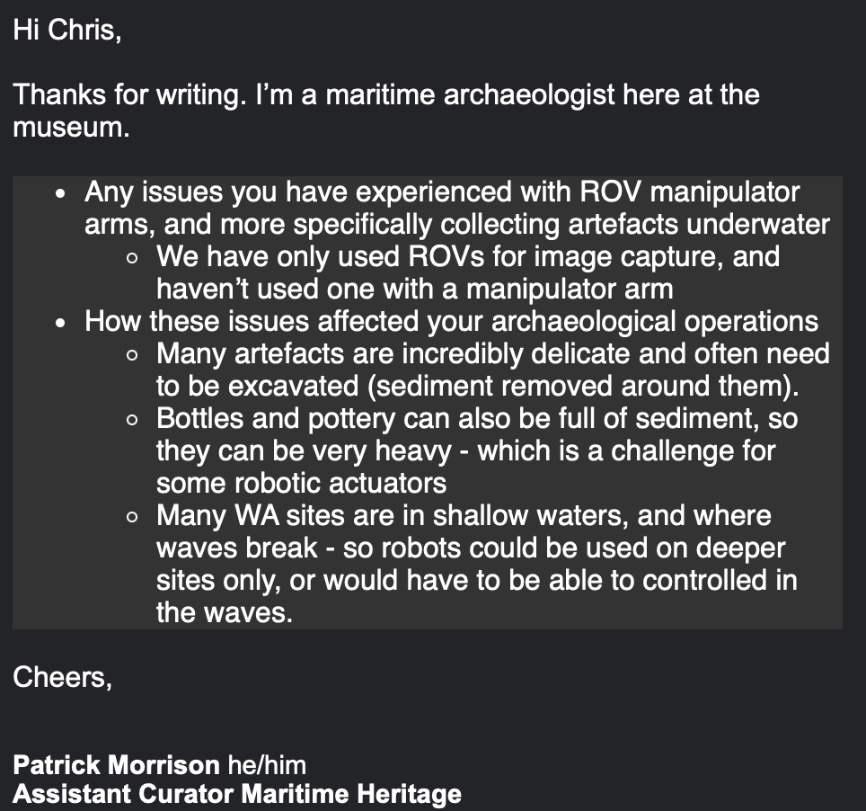
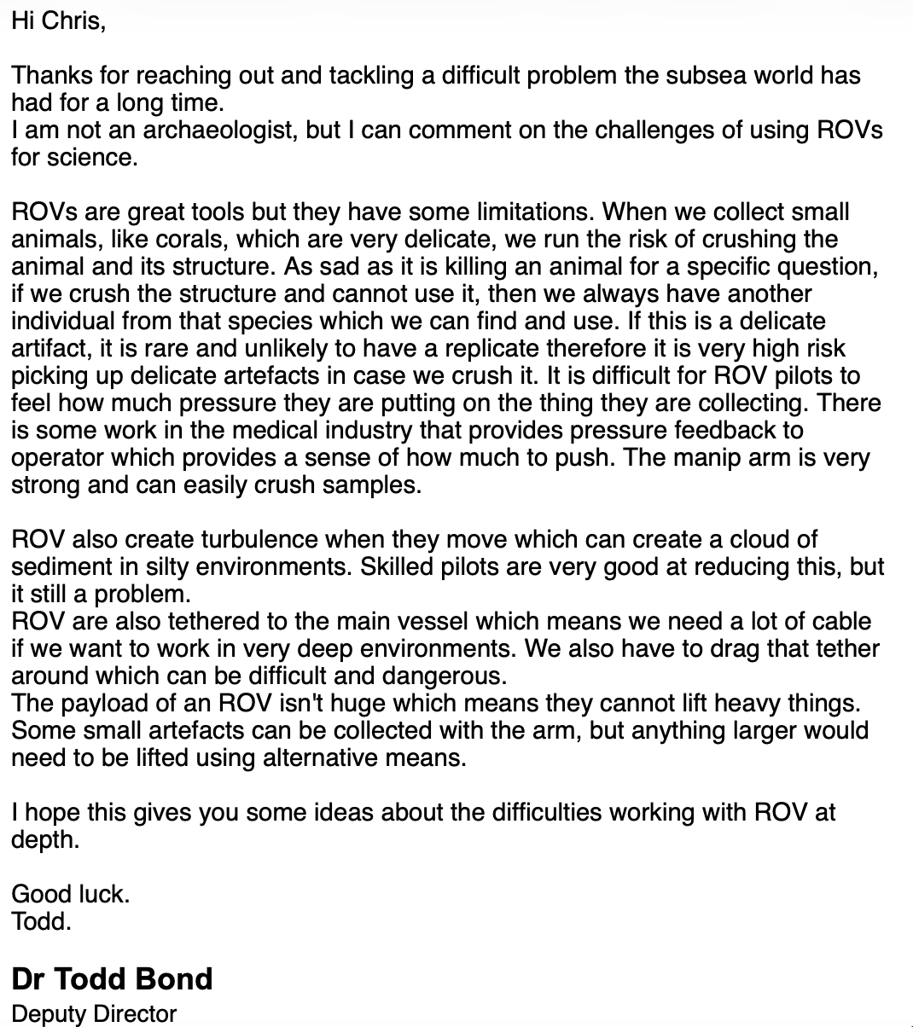

Innovations Play
Roles:
- Presenter 1 and 2 (main talker x 2) – medium parts, 1 is slightly more than 2
- Scientist (gives critical info like stats and other things) – long part, facts
- Questionnaires 1, 2 and 3(ask questions x 3) – short parts, ask questions
- Customer 1 and 2 (person who gives feedback x 2) - 1 part, medium parts
Presenter 1 – [Chris] – school formal uniform, MEMORISE
Presenter 2 – [Kingsley] – school formal uniform, MEMORISE
Scientist – [Subesh] – lab coat, you can bring a clipboard for reading off
Questionnaire 1 – [Leven] - casual clothe, MEMORISE
Questionnaire 2 – [Andre] – casual clothe, MEMORISE
Questionnaire 3 – [Aaron] – casual clothe, MEMORISE
Customer 1 – [Oliver] – Construction vest, MEMORISE
Customer 2 – [Sean] – lab coat, MEMORISE
Total: 8
1st Scene – first advertisement:

Presenter 1: have you been having issues with your manipulator arms?

Presenter 2: been unable to hold onto fragile artefacts that you cannot, for the life of you, destroy?

Presenter 1: can’t even pick up a large treasure chest and have been forced to wait costly months while a larger, more advanced and more expensive ROV arrives?

Presenter 2: well, we have the perfect solution for you! Introducing our new, amazing, spectacular manipulator arm!

Presenter 1: with all new adaptable foam to help cushion delicate vases and pottery, and a large grasping area, the Claw Testing Design 4000, or CTD, is the perfect addition to any ROV collection, for the wealthy or the curious.

Presenter 2: And that’s not all. Our arm has been engineered with highly experimental, rotating pads to grip any surface, and to make sure you don’t mess up your next big job.

Presenter 1: but you don’t need to just trust us!

Presenter 2: we’ve brought in our very own scientist to explain to you how important, and feature packed our arm is.

]
2nd scene – scientist and facts:

Scientist: Thank you. Our CTD is made up of multiple different materials. For the main structural components and frame, we would prefer to use titanium, due to its high strength and high corrosion resistance, however for a cheaper option we can go with anodized aluminium, which provides many of the same advantages as titanium, however with a cheaper material and production cost. For the manipulator fingers, internal structural supports and filler material, we would use plastics and composites to hold electronics and sensors in place. They are a great deal lighter than the structural materials, however, are still quite strong and are corrosion resistant. It also reduces the weight of our arm by around 20% compared to similar sized and spec-ed commercial arms like the Titan 4, which also has the same 6 Degrees of Freedom as our designed arm.

Presenter 1: but what about delicate artefacts?

Scientist: well, I’m glad you asked! Our arm has soft expanded polyethylene foam, that can compress up to, while also providing good grip on objects. Coupled with our adaptable arms, which allow us to always maintain good connection with artefacts by having the grippers rotate to the direction of the object.

*show grippers and how they work*

Presenter 2: (look impressed) wow! That’s a lot of features to help keep artefacts safe and together.

3rd scene – Questionnaires:

Questionnaire 1: Hmm. I’m sceptical. What facts are we talking here?

Scientist: We have a couple predicted facts that are based on existing models. Unfortunately, we have been unable to create a perfect commercial arm and haven’t been able to test them in real world conditions. However, based on our testing and research, we believe our arm will be able to reach depths of over 6,000 meters under the water, have a reach of 2 meters

Questionnaire 2: So, you’re saying your arm is mainly theoretical. Well, what research can you give us to back your claims?

Presenter 1: Well, if you flip to page 4 of our innovation document, you will find all our listed research, as well as a large table of common commercially available arms, with their different specifications. As you can see, we have quite a lot of research to base our claims on.

Questionnaire 3: Well, how does it compare to those models? Wouldn’t it be better to buy an existing, tested model?

Scientist: Of course, our model is an experiment prototype. However, with our testing and new innovations, we are confident that our model we be able to make a sect in the market.

Questionnaire 1: what are those innovations you speak of?

Presenter 2: I’m glad you asked! Firstly, we have the rotating grippers. This allows us to always have most, if not all our gripping surface on the object, allowing for more grip than a standard setup. Secondly, we have removable fingers, allowing users to quickly change out the length and shape of the fingers. Finally, we have installed pressure pads to the grippers, which can give information back to ROV pilots and help with collecting delicate artefacts. These three innovations will be able to compete with more established brands.

Questionnaire 2: what about the long-term use and reliability?

Presenter 1: well, a common manipulator arm is the Schilling Titan 4, which has been tested under full load for 250,000 underwater cycles with minimal wear. However, part changes between years are common, especially for the high friction or wear parts like the O-rings or actuator bushings. Our prototype should have a life span of around 7 years, with major part replacements like actuators and structural components every 2 year, thanks to our corrosion resistant materials and good structural design.

4th scene – customer reviews:

Questionnaire 3: do we have any real customer experience?

Presenter 2: Yes!

Customer 1: Hi! I’m an archaeologist who specialises in recovering artefacts from within shipwrecks. Recently, we had issues with trying to pick up loose rocks from the seabed, especially with the currents making it difficult to position the gripper so that we wouldn’t lose it. In this case, the CTD would have been a great help, as the adjustable fingers would have made errors in positioning have a lesser impact on the chance of picking up the rock sample.

Customer 2: Nice to meet you! I’m a scientist who uses ROV manipulator arms to pick up small animals, like coral. However, when we do try and pick them up, we run the risk of damaging them or even killing them, as the arms are very strong. It is very difficult to know how much force to use when trying to pick them up, as there is no direct form of pressure sensor or similar. However, if we were using the CTD, then we would be able to know how much pressure we are exerting and be able to test how much pressure would damage a coral sample, making it easier to not damage samples.

5th Scene – final advertisement:

Presenter 1: well, as you can now see, our CTD] will revolutionise the ROV manipulator arm scene, with our new innovations-

Scientist: -engineered with innovation and adaptability in mind-

Presenter 2: so, whether your exploring ancient underwater ruins or hauling up century old treasure chests –

Presenter 1: - the CTD will adapt to your mission, task, and environment!

